Your Very Special Destiny
May 7, 2016

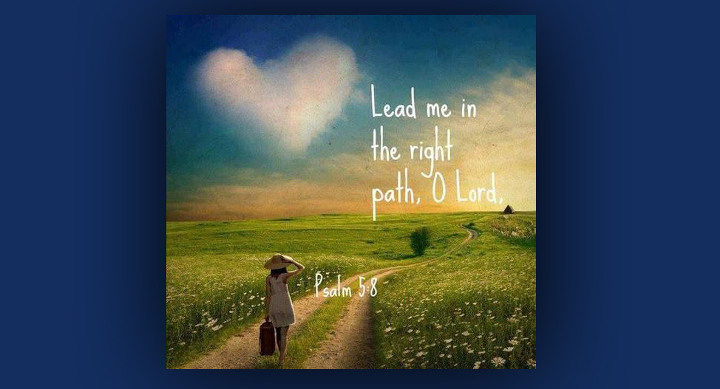
The sweet Presence of Jesus be your consolation and hope, dear Heartdwellers.

I asked the Lord, "What's on Your mind today, Lord?"

And He answered me, "Brevity. The brevity of life and how I wish for you all to make the very best of it. That does not mean conforming to the will and norms of the world. No, it means seeking Me until you find Me and conforming to My will.

"You see, the world has its own agenda and it shouldn’t take much thought on your part to discern who’s behind that. It is rigged so that you will be streamlined right into the place that is convenient for the world and its norms, not for your individuality and who I've created you to be, who you truly are, and what gifts you’ve been given. Those that are lying dormant that you're not aware of.

"It takes a strong soul to think outside the box and swim against the current. A very strong soul. Some are endowed with this strength, others can obtain it or even gain more from Me. Either way, when you and I work together, I will fulfill My agenda for your life. You walk in a supernatural anointing that will carry you through every storm.

"Most have had their dreams stolen at a very young age. They are taught that money is the norm, security and respectability is essential and those become your life goals without even thinking about it. How terribly this strips the soul of incentive! The unique qualities I’ve endowed them with just wither in the heat of these demands. Before a soul strikes out on any endeavor, he asks himself, 'Can I make money? Will I be secure in this work? How can I build my life with this work?' Those are sad, sad questions, totally missing the point of life and the things that will bring you the most joy.

"People with musical gifts 90 percent of the time abandon the idea of living as a musician and sign up selling insurance, or as store clerk, or a desk job where 5% of their ability is called upon to do a job. Some dedicate their lives to advanced training in universities so they can make more money, in the hopes that that will buy them the free time they so long for to devote to their music.

"Do you see, Clare? The most profoundly beautiful parts of a soul’s life are cut off before they can mature.

"My Heart is that every soul is endowed with skills and gifts that bring joy to their work and those they serve. Every soul has something to give that fits into the scheme of things and makes the world a more joyful and rewarding place. These are the little things that are so often overlooked in favor of security and respectability.

"These gifts are either tangible or intangible - like prayer. When a soul finds this gift, he should embrace it with his whole heart and never let it go in favor of a carnal agenda or the agenda of his parents. Your parents have lived their lives and made their choices. You now, in turn, have the opportunity to make your life count in this world in the time left to you.

"Very soon now, the world will be catapulted into survival mode and that will open opportunities for you all to take another look at your lives and where you were headed. But until that happens, I am calling you to press into My Heart. Dwell in My Heart. Do good wherever you find an opportunity, grow in virtue and fight against the temptations that assail you, even by calling your love for Me to mind. A demon cannot gain control of a heart that is full and running over with Love for Me.

"As you grow in virtue, I will begin to release to you the secret dreams of your heart. The pure ones, not the concocted ones that feed the ego, the bank account, or your popularity. No, the ones from Me, planted there to someday be activated and grow into a tree that bears sweet fruit and shade for the birds of the field.

"Some of you have had glimpses of this place but not the courage to pursue it. The courage will come from Me. I will anoint you, open doors and bring you along by a way you’ve never thought possible. I will lead you down crooked paths that result in a straight line to the destiny I planned for you before you were sent into this world.

"My ways will make no sense to you. I may tell you where I am taking you, but you mustn’t run ahead of Me. I have to take you through many layers of lessons before you can function safely and eventually shine in your calling. Each thing you do, each job you have will prepare you for the next. I will give you joy at each step along the way. You will know you are in the right place, because you will feel a certain peace. Saying, 'Yes, this feels right. I don’t know what You’re doing, Lord, but this does feel right. It feels like You.'

"The greatest danger is for you to take things into your own hands and say, 'Well, He’s given me this vision, so I’d better do this next.' That is why you must dwell in My heart. I will lead you with My Love and you will have a peace that is beyond what the world gives you, even in the lowliest of positions, even in the most difficult circumstances. You will have My peace."

And at that point, I was thinking of the mistakes I've made in running ahead of the Lord when I had a vision, or He gave me a word about something. The Lord wanted me to share it.

And I said, "Oh Lord, this is awkward."

"Transparency always is when you’re not perfect. Please share with them?"

Well, I knew that someday I would be leading a community of sorts. I knew the Lord was going to use me in a teaching and healing the inner man capacity. And I had an extreme love for the wilderness. I imagined this community would be in the wilderness of the Sangre de Cristo mountains, and the Lord even pointed out the land. So, we obtained this land and built several buildings on it. People came sporadically, but Ezekiel and I did not yet have the maturity to lead a group and we had internal family issues that really needed to be resolved first.

Nevertheless, I held onto this dream, along with the dream that we would be traveling in an RV and meeting people all over the country and the Lord would draw them to a community. I was so frustrated when the Lord made it clear we were not to have an RV and things on the mountain were not solid enough to include others.

I remember, we went shopping for an RV and found one that was perfect. We were going to buy it, but that night the Lord began to show us that was NOT His will. I remember saying, “But Lord!!! How are we going to travel? You know I can’t stand motels.” But He was silent.

So, we started attending a local church, getting to know people and we found they were totally uninterested in our spirituality. Just...blah. Just totally uninterested. We had one meeting here and it was a flop. Again, this was done in my own will and in my flesh. It was never meant to happen in this town.

Never did I expect for Him to build a cyber community of people from all around the world who were hungering for intimacy with God. Never in a million years did I expect that. What I thought He wanted and what He really wanted were miles apart. But He did insist I work hard on teachings on YouTube and eventually His true will manifested in a community of souls unlike any other, souls who loved the Lord in a deep and profound way and loved each other. I say "like no other community," because I’ve not found one of YouTube channel with people as sweet and good and dedicated to the Lord, and mature and loving as you guys.

But the bottom line is, I tried to make it happen on the mountain. I tried to make it happen traveling, and that was my idea of how to make it happen. So, my advice to you all is, let Him do it His way and don’t for one moment try to assert yourself and your way.

At this point, the Lord cut in and said, "And that’s the crux of the issue. Let Me do it My way. I will lead you step-by-step if you live in the present time, according to My precious will. I know where I am leading you. In many cases, I have put a spark of love in your life for the very thing you will one day be doing. I will confirm it to you. But then you must let go. Just as Abraham knew his descendants would be as numerous the stars in the heavens and the grains of sand, He didn’t do it with Hagar the slave woman. Rather, He did it miraculously with Sarah.

"Yes, I love to do things miraculously. I love to get the credit. I love to see the hopeless come to life when I breathe My promises into their hearts and minds. And there is no better way to draw them to Me than by your holy example as you live the life I’ve called you to and carry your cross.

So, My children, let me encourage you now, You have a very special destiny, each and every one of you. One that only you can fulfill - no one else can fulfill it. Seek Me until you find Me and I will reveal it to you.

"I bless you now with a hunger for Me and My calling for you."

I'd just like to take an aside here and just share something with you. Some of you have worked your whole lives in the Lord’s vineyard and are waiting for the trumpet to sound to be taken to Heaven. Others of you are young and know you are called to live a life here on Earth and not go in the Rapture. Still others are hearing this message for the first time. The Lord wants you to understand that life is full of surprises, and the unfolding of your life is certainly one of them.
That’s built on intimacy with Him in prayer. It is a deep and abiding heart-relationship with your Creator and best friend. To worship and adore Him in spirit and in truth brings you into the throne room of His heart where all life and joy is manifested.

The Lord is not a pigeon-holing God. No, not at all. He is unique, just like all the life forms around you, and each of you are born for such a time as this, with gifts of grace that will make a difference in the world and draw others to His Kingdom.

So please, don’t think for one moment that being a Christian is a boring life of conformity. Because it is anything but! I’ve followed Him for almost 40 years and I can tell you that living for Jesus is the most wonderful adventure anyone on this Earth can have. It is supremely rewarding. And the sweetest thing you will ever experience in your life is His Love for you. As well as the deepest challenges and pain as you carry your cross the way He has asked you to.

“Deny yourself, pick up your cross and follow Me.”

He will empower you every step along the way. He will protect, strengthen and complete the good work He has begun in you. Don't be afraid to lay your life down at His feet and say, "Lord, whatever Your will is for my life, I give You my life to live." And remember what He said:

He who would save his life will lose it, but he who will lose his life for My sake will find it. Matt 16:25

